OFFICIAL COORDINATION REQUEST FOR NON-ROUTINE OPERATIONS AND MAINTENANCE

COORDINATION TITLE- 14TDA13 back up AWS survey updated
COORDINATION DATE- 18 December 2014 updated on 10 March
PROJECT- TDA
RESPONSE DATE- 8 January 2015 (FPOM). For updates - 12 March 2015 (FPOM)

Description of the problem- P&S for The Dalles AWS auxiliary system are being prepared. Construction is anticipated to take place over two in-water-work windows. There is some construction work (tremie concrete and placement of the cofferdam/trashrack) that could be sensitive to flow conditions. Data was collected early in FY15 and showed little to know change in the flow conditions at the construction site with powerhouse operations. The total river was quite low but still no noticeable change. By collecting data on April 9 (no spill) and April 10 (spill) we should see how a impactful changing project operations are on the flow conditions at the construction site. In addition it is anticipated that the flow will be significantly larger on April 9th/10th.

Additional measurements needed include a hydroacoustic survey of the forebay wall at the construction location for the intake structure. Dates that the additional wall measurements would occur – Half a day on April 8th with standard powerhouse operation and no spill, or on April 11th with standard powerhouse operation and 40% spill. Operations and forebay hydraulics shouldn't make much difference (spill vs no spill) for the data collection on the wall.

14TDA13 attachment 1 velocity shows unit operation requests during the survey. 14TDA13 attachment 2 transects shows a 100' radius fish haven around the 3 ladder exit slots, see Attached Figure. 7 transects and 2 stationary measurement locations encroach on the fish haven site. On each of the transects, the boat will be idling through the fish haven for no longer than 5 minutes, for a total of no more than about 35 minutes per day. Each stationary point involves the boat idling with its bow pressed against the face of the dam for 10 minutes. Grand total of 45 minutes within a 100 feet of the fish ladder. Ideally all of the stationary points would be collected but S-
03 could be dropped.

Data Collection has to be during daylight hours and we would be better after power peaking hours in the morning. Start around 9 or 10 AM. Work within the 100’ buffer will occur between 1200
– 1500.

Type of outage required- Requested unit operation will not differ from FPP criteria. Adult fish facilities will not be impacted other than the survey boat being within 100’ of the exit.

Impact on facility operation – Please see 14TDA13 attachment 1 velocity. This shows how the operations will change between the 9th (no Spill) and the 10th (spill). The goal is to have the total river on the 9th and 10th approximately the same.

Dates of impacts/repairs- 9 and 10 April 2015.

Length of time for repairs- Data Collection will take approximately 6 to 7 hours per day with data collection within 100 feet of the fish ladder for approximately 45 minutes each day.

Expected impacts on fish passage- Impacts for both downstream and upstream migrants are expected to be minimal.

Upstream Migrants – Based on TDA 10 year average fish passage information from DART in Figure 1, fish counts are very low in early April when compared to May or summer months. The survey work will be completed before the fish runs pick up.
Based on the diel passage data in Figure 2, work within the 100’ buffer will be restricted to 1200– 1500. This should avoid the morning and afternoon passage peaks.

Lamprey – This work will occur outside the normal adult lamprey migration season. Juvenile lamprey will likely not be affected by the work since the ITS will remain in FPP criteria.

Downstream Migrants – In Figure 3, JDA smolt index figures for 11 years show relatively low smolt passage in early April. Looking at Table 1 it would appear that a maximum of 2.5% of the migrating juveniles in April have the potental to be impacted by the work proposed on 9 – 10 April as well as the wall survey that would occur on 8 or 11 April. JDA SMP personnel estimated travel time between JDA and TDA to be a day or two depending on flow. With this work taking 14 hours over a couple of days, impacts to the juveniles passing TDA should be minimal, especially once spill starts on 10 April. The ITS will remain in FPP criteria for the duration of the survey.

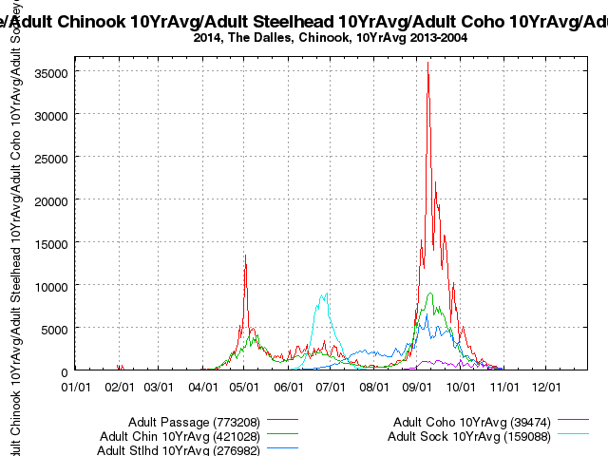
Figure 1. 10 year adult salmon passage at The Dalles Dam.

DART Data Citation Columbia River DART, Columbia Basin Research, University of Washington. (2014). Available from http://www.cbr.washington.edu/dart/query/adult_graph_text
Generated 17 Dec 2014 16:14:33 PST. Columbia River DART (Data Access in Real Time) www.cbr.washington.edu/dart.

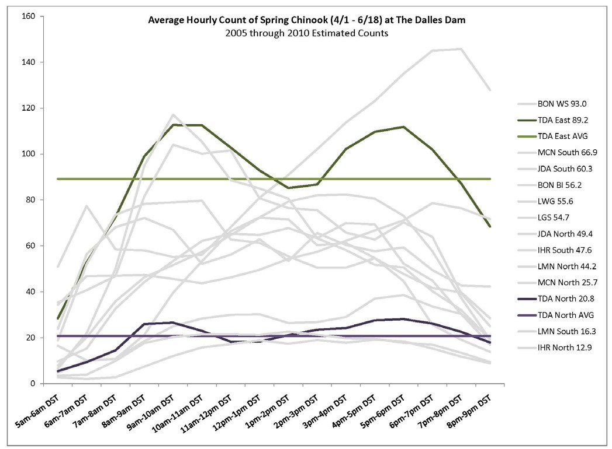
Figure 2. Diel Passage for spring Chinook at The Dalles Dam.

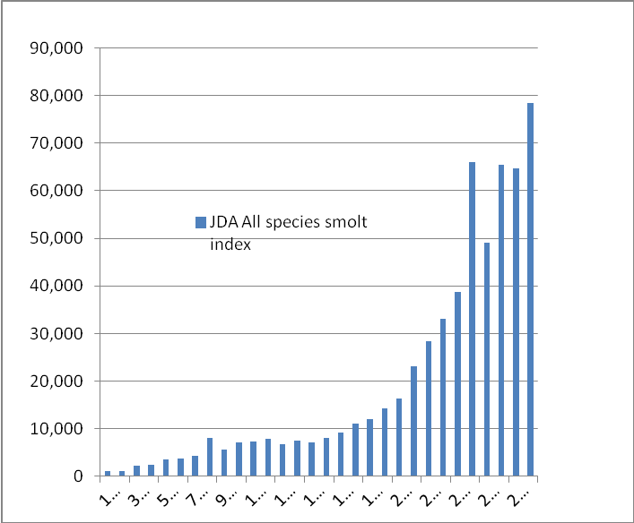

Figure 3. John Day Dam 11 year smolt index for April 2004 – 2014.

Table 1. JDA 2004 – 2014 Smolt Index for 9 – 10 April.
Smolt Index Estimates
JDA 2004 - 2014, all species combined.

Average
Daily % of

Avg Daily %
of Monthly

2004 2005 2006 2007 2008 2009 2010 2011 2012 2013 2014 Daily avg. season total
total

9-Apr | 1,930 | 3,486 | 1,984 | 2,113 | 2,815 | 530 | 52 | 18,291 | 25,319 | 4,006 | 1,395 | 5,629 | 0.1% |  | 0.9%
10-Apr | 3,180 | 4,442 | 3,377 | 1,890 | 5,461 | 633 | 84 | 39,637 | 12,850 | 4,523 | 1,704 | 7,071 | 0.1% |  | 1.2%
11-Apr | 5,190 | 4,835 | 4,354 | 2,932 | 3,018 | 774 | 190 | 44,983 | 7,059 | 4,117 | 2,013 | 7,224 | 0.1% |  | 1.2%
12-Apr | 4,972 | 2,736 | 6,190 | 4,350 | 2,574 | 1,418 | 196 | 50,802 | 3,998 | 7,383 | 1,940 | 7,869 | 0.1% |  | 1.3%

Comments from agencies
CRITFC - -----Original Message-----
From: Tom Lorz [mailto:lort@critfc.org]
Sent: Wednesday, December 24, 2014 9:36 AM To: Mackey, Tammy M NWP
Subject: [EXTERNAL] Re: FPOM: Official Coordination - 14TDA13 back up AWS survey
Why oh why are they not doing this work in say, January early Feb???????? In water work done in water work window would make sense. If they have to do the work then I would suggest do any work near the fish entrance last if at all. Not happy about the time of year, yes not likely to be too many fish but come on we have an in water work window for a reason.

NWP-HD -----Original Message----- From: Ebner, Laurie L NWP
Sent: Wednesday, December 24, 2014 11:28 AM
To: Mackey, Tammy M NWP; Rerecich, Jonathan G NWP
Subject: RE: [EXTERNAL] Re: FPOM: Official Coordination - 14TDA13 back up AWS survey
(UNCLASSIFIED)
Classification: UNCLASSIFIED Caveats: NONE

The reason we are doing it then is because we want to initiate as much of a change in the velocity signature at the fish ladder exit and doing that when we shift from non spill to spill is our best opportunity.

If the counts are high on the day we choose to do this we can avoid the circle drawn on the map. What would a high count be? By doing this we don't get the actual data at the fish ladder and would be inferring the impact.

The optimum goal is to be able to construct the AWS in the in water work window given whatever river conditions we are provided. If we do the test in January or February it is a crap shoot how much flow we will have and if we can modify the powerhouse operations sufficiently enough to do see a change at the fish ladder exit. If we don't elicit an impact at the fish ladder with the shift from non spill to spill nothing we do at the powerhouse will elicit a change.
Laurie Ebner CENWP-EC-HD Phone: 503-808-4880
Fax: 503-808-4875

-----Original Message-----
From: Ralph Lampman [mailto:lamr@yakamafish-nsn.gov] Sent: Tuesday, January 13, 2015 1:49 PM
To: Mackey, Tammy M NWP
Cc: Bob Rose; Aaron Jackson; Statler, Dave; Tom Skiles; Brian McIlraith
Subject: [EXTERNAL] Fwd: FPOM: Official Coordination MOC 14TDA13 AWS back up survey
Hi Tammy,
I didn't want to reply to all, but since larval and juvenile lamprey migrate in April, seem like it should warrant a little more discussion on lamprey for this non-routine operation (it just said this work will occur outside the normal lamprey migration season - which is true for adults, but not for juveniles). Just wanted to make sure the juvenile lamprey migration is not forgotten.

Thanks,
Ralph Lampman
Yakama Nation FRMP, Pacific Lamprey Project lamr@yakamafish-nsn.gov

Final results: Approved at the 8 January 2015 FPOM meeting.

Please email or call with questions or concerns. Thank you,

Jon Rerecich
NWP PM-E Columbia River Bio
503-808-4779
Jonathan.G.Rerecich@usace.army.mil

